**3D joint inversion of induced polarization and self-potential data for ore localization**

Zhaoyang Su (1), Jinsong Shen (2), André Revil* (3)

Zhongmin Zhu (4), and Ahmad Ghorbani (5)

(1) College of Safety and Engineering, Anhui University of Science and Technology,

Huainan, 232001, China

(2) College of Geophysics, China University of Petroleum, Beijing, 102249, China

(3) Université Grenoble Alpes, Université Savoie Mont-Blanc, CNRS, UMR CNRS 5204, EDYTEM, 73370 Le Bourget du Lac, France

(4) Institute of Polar and Ocean Technology, Second Institute of Oceanography, MNR, Hangzhou, 310012, China

(5) Naga Geophysics, Technolac, 73370 Le Bourget du Lac, France.

**Corresponding author:** André Revil ([andre.revil@univ-smb.fr](mailto:andre.revil@univ-smb.fr))

**Emails:** [2425554377@qq.com](mailto:2425554377@qq.com); [shenjinsongcup@163.com](mailto:shenjinsongcup@163.com); zhuzm@sio.org.cn [ahmad.ghorbani@naga-geophysics.com](mailto:ahmad.ghorbani@naga-geophysics.com)

**Running title:** Joint inversion of IP and SP data

Intended to be published in *Geophysics*

**Abstract.** Induced polarization (IP) and self-potential (SP) are two broadly used active and passive geophysical methods in mineral exploration. These methods are associated with charge distributions beneath the ground surface or seafloor, generating by polarization currents or naturel electrochemical reactions at the surface of an ore body. The inverted chargeability and source current density from IP and SP inversion both reflect the structure of ore bodies. Joint inversion using the cross-gradient constraint of IP and SP data is expected to improve the accuracy of geophysical imaging of these targets. In this paper, a joint inversion approach is applied to IP and SP data in the context of ore exploration. The objective function to minimize includes three components, two independent parts plus a cross-gradient joint function. This method overcomes some problems like convergence and parameter determination in the inverse process. Numerical synthetic tests and a sandbox experiment show that joint inversion reconstructs the chargeability and current density distribution better than independent inversion results. For a more refined interpretation, we calculate an ORe body Index (ORI) using the normalized inverted model parameters resulting from the joint inversion. We applied the K-Medoids clustering algorithm to automatically categorize the ORI into different clusters. The cluster with larger values successfully identifies the ore bodies associated with strong chargeability (IP) and/or source current density (SP).

# Introduction

Mineral exploration is becoming increasingly challenging since large and shallow targets are mostly exhausted (Okada, 2022). Geophysical technologies provide non-invasive and cost-efficient methods presently broadly used in mineral exploration. This is especially true regarding the use of low-frequency geoelectrical methods such as the Electrical Resistivity (ER), Induced Polarization (IP), and Self-Potential (SP).

IP and SP data are associated with the charge distributions beneath the surface or seafloor (Everett M., 2013). Ore bodies can be polarized and the charge distributions are established by the injection of primary current (electric field) in IP survey (Schlumberger, 1920; Hallof et al., 1990; Seigel et al., 2007; Li and Oldenburg, 2000; Revil et al., 2015, 2022; Casulla and Mizunaga, 2023). Negative SP anomalies generated by subsurface natural current sources are associated with redox-active environments where ore bodies are located (especially because of the decay of oxygen concentration/fugacity with depth, see Sato and Mooney, 1960, Revil and Jardani, 2013). Sultan et al. (2009) reported a multi-geophysical survey at Wadi EI Beida to delineate the mineral ore deposits, including the magnetic, IP and SP survey. Horo et al. (2020) combined SP, ERT and IP data together estimated depths of gold prospective zones. Nakayama and Saito (2018) measured magnetic, IP and SP anomalies at hydrothermal deposits below the seafloor. Most metal deposits consisting of disseminated semiconductors (such as pyrite and magnetite) exhibit polarization effect and may generate SP anomalies. The inverted chargeability and source current density both reflect the structure of the ore bodies with complementary spatial sensitivity with respect to such targets.

However, clay-rich materials can also generate strong IP effects (Hoversten et al., 2006; Revil et al., 2023). At the same time, SP anomalies can be associated with groundwater flow through the electrokinetic effect, geochemical gradients (through diffusion and membrane polarization mechanisms), and temperature gradient (through the thermoelectric effect) (see Revil and Jardani, 2013, for a description of the various mechanisms). The interpretation of IP or SP data alone may lead to errors in the interpretation of their position. Therefore, integrating these methods through joint inversion may help to better characterize ore bodies.

The joint inversion of multiple geophysical data can be done with a variety of approaches. Currently, two main types of joint deterministic inversion methods have become very popular. One is using cooperative petrophysical relationships between different physical properties (e.g., Harris and MacGregor, 2006; Lelièvre et al. 2012; Sun and Li, 2016, 2017; Xu et al. 2021). The second is based on the structure similarity (Haber and Oldenburg, 1997; Zhang and Morgan, 1996, Gallardo and Meju, 2003). Gallardo and Meju, (2003, 2004, 2007) introduces a cross-gradient product as a joint function into the objective function to minimize. This technique is currently well-known and broadly accepted in the community developing joint inversion of multi-geophysical datasets (see for instance Linde et al., 2006; Tryggvason and Linde, 2006; Hu et, al, 2009; Moorkamp et al. 2013; Revil et al., 2013; Gross, 2019, just to cite a few). It is also possible to integrate both petrophysical relationships and structure constraint into the inversion process (see Colombo et al., 2012a, b). The different constraint terms in the joint inversion process may also be guided by the prior geologic knowledge available (Lelièvre et al., 2012).

Despite the fact that joint multi-geophysical inversion methods with a single objective function may improve the consistency and resolution of the inverted model parameters, new challenges are introduced in such inversion schemes (see details in Um et al. 2014). These challenges include:

(1) Variability in the petrophysical relationships. Petrophysical relationships (type and nature) may vary across different regions of the investigated domain;

(2) Complexity of full joint investigation. 3D full joint inversion with cross-gradient constraint is nonlinear. Ensuring convergence of the inversion may be challenging. The iterative inversion process may easily be trapped in local minima of the objective function;

(3) Difficulty in determining weight factors. Determining appropriate weight factors and regularization (trade-off) parameters in the objective function can be difficult, and choosing inappropriate parameters may lead to inappropriate inversion results.

(4) Computational cost. When using a gradient-type solver to solve the objective function of joint inversion, explicit calculation and storage of the Jacobian (sensitivity) matrix are necessary steps that require additional storage and increase computational costs. Addressing these changes is crucial for the successful application of joint inversion methods in geophysical exploration.

Um et al. (2014) proposed a coupled inversion approach for seismic and electromagnetic data, and then used to image the structure of geothermal field (Um et al. 2023). In contrast to the traditional joint inversion, they split the objective function to small parts, reducing the complexity of joint inversion and achieving consistent and high-resolution result. Based on this idea, Gao et al. (2016, 2018) introduced another joint inversion strategy for seismic data and ER data. The key point of this strategy is that the model perturbation  is obtained from independent inversion at each iteration, and then a new model perturbation  is updated using the cross-gradient constraint. This step ensures the consistency of different model parameters. The coupled or joint inversion methods mentioned above have proven to be both effective and stable. Moreover, we do not need to explicitly calculate the Jacobian matrix, and it is easy to transfer the code of independent inversion to joint inversion of other multi-geophysical datasets.

Following the methodologies introduced by Um et al. (2014) and Gao et al. (2016, 2018), we have developed below a joint inversion strategy with cross-gradient constraint for IP and SP data in the context of ore body exploration. The joint inversion is applied to two case studies and a sandbox experiment is used to demonstrate the effectiveness of the approach. The results demonstrate that the joint inversion provides better solution of the ore bodies and reduce the date misfits. For a more refined interpretation of the results, we have also introduced an ORe body Index (ORI) and a K-Medoids clustering algorithm to enhance the accuracy of exploration of ore deposits using SP and IP datasets.

# Methodology

## Induced polarization (IP) modeling and inversion

In time-domain induced polarization (TDIP) method, the apparent chargeability (IP data)  (dimensionless) is calculated by (Oldenburg and Li, 1994)

, (1)

where  denotes the “instantaneous” potential difference between two voltage electrodes when the primary current is injected into the ground, and  denotes the steady-state or DC potential when the current is injected for a long time,  (dimensionless) denotes the intrinsic chargeability of the medium. Polarization effect can be treated as a perturbation of the subsurface conductivity (Seigel, 1959), i.e.,  where  (in S/m) denotes the instantaneous conductivity (without polarization effect) and  denotes the Direct Current (DC) electrical conductivity. When an electrical field is applied to a porous medium, all the charges are mobiles while in DC conditions, the charges immobilizes through polarization do not participate anymore to the conduction process (i.e.,  > ).

The potential  can be calculated by solving the following Poisson’s field equation (Pidlisecky et al., 2007),

, (2)

where  (in A) denotes the injection (positive)/retrieval (negative) electrical current at the ground surface,  is the Dirac delta function,  and  denote the locations of the positive and negative current sources (located at the current electrodes A and B), respectively. We substitute the Direct Current (DC)-conductivity  to the instantaneous conductivity  in equation (2), and the potential difference  can be obtained by re-running the forward model for the DC condition. Since equation (2) is also the governing equation for the electrical resistivity, the apparent chargeability  is simply computed by carrying out two electrical resistivity forward models with the conductivities  and  (see Oldenburg and Li, 1994, for details).

The objective function for the inversion of IP data can be written as follows:

 (3)

where  denotes the vector of observed IP data (apparent chargeability ) and  denotes the vector of predicted data,  is the inverted chargeability model,  is the reference model,  is the diagonal data-weighting matrix,  is the roughness operator used to obtain a smooth inversion result. The regularization parameter (trade-off)  is used to balance the data misfit term (first term in equation 3) and the model constraint term (second term in equation 3).

## Self-potential (SP) modeling and inversion

The total current density  (in A/m2) is the sum of two contributions: Ohm’s law (associated with the transport of electrical charges by conduction) and a source current density (associated with the redox action around the ore bodies) (Sill, 1983),

 (4)

where  denotes the (DC) electrical conductivity of porous material,  is the quasi-static electrical field, and  (in V) is the electric potential,  (in A/m2) is the source current density. In the low-frequency domain of the Maxwell equations, the conservation of total current density is given by,

 (5)

Combing equations (4) and (5), the SP governing equation is,

 (6)

where  (in A/m3) denotes the volumetric source current density corresponding to the source below the ground surface.

We incorporate the minimum support (MS) function and depth weighting to the objective function for the SP problem. The MS is defined as (Last and Kubik, 1983),

, (7)

where  denotes the number of cells,  denotes the inverted model at the previous iteration (), and parameter  is a small threshold value (Zhdanov and Tolstaya, 2004). The depth-weighting matrix is used to avoid to find only sources close to the recording stations, and it is defined as

, (8)

where  is the number of observed SP data,  are the elements of the kernel matrix  (which is the collection of the Green functions of the problems including the effect of the conductivity distribution). Combining the use of the MS function and depth-weighting matrix, a diagonal weighting matrix  is defined as

. (9)

The new kernel matrix is , and the objective function for the inversion of the SP data is defined as (Minsley et al., 2007; Jardani et al., 2008; Mendonça, 2008),

, (10)

where  denotes a reference model for the source current density. The solution  can be obtained by solving the equation (10). According using , the depth-weighting source current density  is obtained using a direct solution or a Gauss-Newton approach.

## Joint inversion of IP and SP data

A conventional least-squares joint inversion formulation with cross-gradients constraint for two different types of data can be written as (Um et al, 2014),

 (11)

where  and  are scalar parameters that control the weighting of data misfit,  and  are the regular (trade-off) parameter,  and  are IP and SP data weighting matrices,  and  are roughness operators, and  are the predicted IP and SP data during the inversion, and  are the observed data,  and  is inverted chargeability and source-current density,  and  are the reference model vectors for the IP and SP problems, and  is the weighting factor that controls the degree of similarity between the inverted two models for IP and SP.

The objective function (11) can be solved directly using Least Square QR-factorization (LSQR) algorithm (Paige and Saunders, 1982), However, choosing appropriate weighting parameters (,  and ) and achieving a balanced trade-off between each term is known to be a challenging problem in itself. So, it is not be easy to globally minimize the objective function (11) (see discussion in Um et al., 2014). In addition, when directly solving equation (11), there is a need to compute and store the sensitivity matrix explicitly, which actually demands a high computational cost. To overcome above issue, we could split equation (11) into several inversion components (Um et al. 2014, 2023; Gao and Zhang, 2018; Domenzain et al. 2023). Here, the equation split into three small inversion subsets:

, (12)

, (13)

, (14)

where  denotes the data misfit term (equal to the first term in equation (3) or equation (10)) and  denotes the model constraint term. It is equal to the second term in equation (3) or equation (10). The weighting parameters  and  are used to balance the weights of the model perturbation, and prevents the updated model perturbation changing too much due to the cross-gradient constraint. Parameter  is used to control the cross-gradient constraint, thereby ensuring the convergence of the individual inversion at the next iteration. The cross-gradient function is defined as (Gallardo and Meju, 2003, 2004, 2007)

, (15)

where the  and  are the gradient of chargeability model (dimensionless)and volumetric source current density model (in A/m3), respectively. Model  and  both are linked to volume-based distribution, and reflect the structure of the ore bodies (Figure 1). According to equation 12-14, the joint inversion can be solved by three steps: (1) Solving the IP inversion using a gradient-type method during the iteration, and obtain the model perturbations (equation 12). (2) Solving the SP inversion and obtain the model perturbation  (equation 13). (3) Combining the solution  and  with the cross gradient function, and update the model perturbation  and  by solving the equation (14). Equation (14) guarantee the common structure of the inverted different models.

We introduce the workflow of independent inversion of IP and SP data (Figure 2). Firstly, we invert the electrical conductivity distribution from ERT. The conductivity  is used to calculate the kernel matrix of the SP problem, this will enhance the accuracy of SP inversion, and eliminate ghosts associated with high conductivity contrasts from true sources associated with ore bodies (see Revil et al. 2013; Su et al. 2022 for a discussion on this point). Then, the independent IP and SP inversions are carried out, respectively. A homogeneous model is used as a starting model for IP and SP inversion. A Gauss–Newton algorithm is used to minimize the objective function. Finally, the model  and  are updated by solving iteratively these equations.

The workflow of joint inversion of IP and SP data in this paper is illustrated in Figure 3. The key point is that after two model perturbation ( and ) is obtained by solving the Gauss–Newton system at each iteration. Then, we continue to update the model perturbation by solving the equation (14). This step will guarantee the two models to have a similar structure. After, we update the inverted models according to . The iteration process continues until the convergence is achieved or the maximum number of prescribed iterations is reached.

To evaluate the different data misfit of the joint inversion, the Root-Mean-Square (RMS) error of IP and SP data is defined as

 (16)

At the first iteration in IP or SP inversion, and the RMS=1. After several iterations, the RMS decreases until a threshold is reached.

## ORe body Index (ORI)

Here, we used an ORe body Index (ORI)  (dimensionless) to delineate the presence of the ore body, the ORI  was calculated from both the inverted chargeability and source current density (Su et al., 2024).

 (17)

where the  and  represent the maximum and minimum value of inverted model parameter from joint inversion,  and  represent the maximum and minimum value of inverted source current density distribution. Actually, the ORI is the sum of normalized inverted chargeability (first part in equation (17)) and normalized inverted source current density (second part in equation (17)). The value of each normalized model between 0 and 1, therefore, the calculated ORI  value range between 0 and 2. According to the value of ORI, we classify the results into three cases: (1)  denotes the background. (2) and  denotes ore bodies only has one of the characters (chargeability or current density); (3) if the ore bodies both showed high chargeability and source current density anomaly, and the value  should close to 2. However, smooth constraint used in the joint inversion, and the boundary of inverted model isn’t clear, so the value  range 1 to 2. Based on the described above, the calculated ORI ≥1 denotes the ore bodies.

## K-Medoids clustering algorithm

Incorporating the fuzzy c-means clustering function into the geophysical inversion has been shown to improve the spatial resolution of geological units (Paasche and Tronicke 2007; Carter-McAuslan et al. 2015; Sun and Li, 2015). In this paper, for improved interpretation, we use the K-Medois clustering algorithm to automatically categorize the ORI result into several clusters. Each cluster is characterized by a unique medoid (cluster center), representing different geological units such as existing ore deposits and surrounding rock bodies. The K-Medoids clustering algorithm, also known as Partitioning Around Medoid, was proposed by Kaufman and Rousseeuw (1987). We calculate the squared Euclidean distance as the measure of distance from each cell to the cluster center, and define the cost function as follows,

, (18)

where  is the number of clusters and is the center of the ith cluster,  denotes the ORI and  is number of data to be clustered. The determination of clusters and their cluster centers follows these steps:

(1) We define the number of clusters as  and randomly select  initial cluster centers.

(2) Each ORI point is assigned to the cluster represented by its nearest cluster center.

(3) For each cluster, a new cluster center is selected to minimize the total distance from all points within that cluster to the new cluster center.

(4) Steps 2 and 3 are repeated until the cluster assignments stabilize or change minimally. Ultimately, the ORI is divided into  clusters. Notably, the cluster with larger values of cluster centers (≥1) are considered to represent ore bodies. A key point is that how to determine the number of cluster centers. We will discuss this point in the next section.

# Numerical case study

We now evaluate the effectiveness of the proposed joint inversion workflow using first two synthetic models. The first model is simply and only a single anomalous body with the consistent structure of chargeability and current density anomaly. The second model is designed to be more realistic, and two anomalous bodies with contrasts in chargeability and current density, similar to the sandbox experiment described below.

## Case Study 1

In most cases, the different petrophysical properties of subsurface anomalies have the similar structure. Here, we design a simple 3D model with one anomalous bodies, and the detailed properties of materials provided in Table 1. The dimensions of the anomaly along the ,  and  directions are all 0.14 m. The model is discretized into a grid of size 40 × 40 × 25, and the fine mesh is 0.02 m3. Newman boundary condition is used in the modeling. IP and SP data are collected by using the same protocol as the sandbox experiment described below. For ER and IP survey, there are total of 237 potential field differences and apparent chargeability data. For SP survey, 64 voltage differences are recorded. Both the initial model and the reference model are homogeneous in independent and joint inversion. We set the weighting parameters as . The lower and upper bounds of the inverted value for chargeability and current density are set to [0, 0.2] (dimensionless) and [0, 2.5×10-3] (mA/m3.) The workflow for independent inversion and joint inversion of IP and SP data with cross-gradient constrain is illustrated in Figure 2andFigure 3, respectively. First, the conductivity distribution is obtained after 5 iterations from ERT (Figure 4a, b). Then, this conductivity distribution as a prior information is used to independent inversion of IP and SP data. Finally, we normalized inverted chargeability and inverted source current density, and calculate ORI using the equation (17) (Figure 4g and h).

The results of the joint inversion are depicted in Figure 5. Both the inverted chargeability model and current density model closely resemble the true model (Figure 5 a - d). The calculated ORI accurately delineates the potential locations of anomaly (Figure 5 e - f). Next, we applied the K-Medois algorithm to automatically categorize the ORI result into two clusters. The cluster with largest value further improve the resolution in identifying the shape of the anomaly. Compare to independent inversion, the cross-plot of model parameters from joint inversion reveals a strong correlation between inverted chargeability and current density (Figure 6a), highlighting the efficacy of the cross-gradient constraint. The histogram of ORI reveals values closes to 2 and further demonstrated the joint inversion ensures a more consistent structure for anomalous. The inverted two cluster center is 0.0105 and 1.495, respectively (Figure 6b), and the cluster center ≈1.5 denotes the anomaly characterized by both the strong chargeability and current density.

## Case Study 2

We now design two anomalies in case study 2. The petrophysical properties of each anomalous body are detailed in Table 2. The dimensions of the first anomaly (C1) are uniform, with values of 0.1 m in all three directions. and the second anomaly (C2) is 0.05 m, 0.05 m and 0.2 m in ,  and  directions. This case study aims to evaluate the effectiveness of joint inversion with cross-gradient constraint when the petrophysical boundaries of anomaly are different. The same inversion workflow used in case study 1, and we set the parameter  and .

Figure 7 illustrates the result of independent inversion. Two anomalies are recognized in the conductivity distribution, but the boundary of the anomalies is not clear (see Figure 7 a, b). The ERT is not sensitive enough to capture such small size anomaly (here, the size of the body should be compared to the smallest electrode spacing). However, the large anomaly C1 is well recognized in the inverted chargeability distribution from IP inversion (Figure 7 c and d), well the anomaly C2 is recognized in the inverted source current density (Figure 7 e and f). The joint inversion with cross-gradient constraint improves the resolution, especially for the chargeability distribution (Figure 8 a and b). Then, we consider the ORI calculated from the joint inversion. ORI tomography reveals two anomalies (Figure 8 e and f), but the boundary of anomaly is not clear. Finally, the ORI are classified four clusters using the K-Medois clustering algorithm, and the determined cluster centers is 0.003, 0.246, 0.790 and 1.466. The part (ORI ) corresponds to the anomaly C1, which only reflected by the chargeability, and the other part (ORI ) corresponds to the anomaly C2 (Figure 8 g and h), which reflected by strong and localized source current density (SP) and strong chargeability values (IP). This is close to the real ORI of anomaly C1 and C2 (1 and 1.5). and the cluster center 0.246 is artifact. Sun and Li (2015) discuss the effects of using an inaccurate number of clusters in joint inversion. If the designed number of cluster center more than the real geologic units, artifact will be surrounding the major velocity anomalous bodies. But if the number of clusters is less than the number of real geologic unit, the anomaly will be vanished into the background.

The cross-plot and histogram of model parameter from inversion are showed in Figure 9. Figure 9 d showed the four clusters: background, anomaly C1 and C2, and artifact, it can be ignored (<0.5). This case study demonstrates that index  after clustering is sensitive to the presence of ore bodies, which are reflected by either strong and localized source current density (SP) and/or strong chargeability values (IP).

# Sandbox Experiment

## Experimental setup

A plastic tank was filled with water-saturated sand, and two metallic bodies are buried into the sand (Figure 10a and b). The dimension of tank is 0.57 × 0.40 × 0.285 m. The anomaly S1 is a metal (stainless steel) can with a dimension of 0.06 × 0.06 × 0.08 m, and the anomaly S2 is a metal bar with a dimension of 0.025 × 0.025 × 0.22 m. Two buried targets are cylindrical shape. Through a vertical plastic tube, a mixed acid solution with a conductivity of 0.031 S m-1 at 24.9 °C, was poured into the bottom of the sandbox. The height of water table was maintained at 14 cm below the surface during the experiment, approximately in the middle of the box (Figure 10c and d).

## Data acquisition

We designed a 2D protocol for ER and IP survey, comprising a total of 17 profiles along the  and  directions. Along each profile, we kept the position of current electrode A and B constant and the position of voltage electrodes M and N is changed for each measurement. The space of the electrode is 6 cm (y direction) and 4 cm (x direction) (Figure 10 a). The voltage difference (ER data) and apparent chargeability (IP data) were acquired using an ABEM instrument Terrameter SAS 4000 (Figure 9a). The injected current duration (time on) is 1s, and the maximum injection current is set to 200 mA. After the primary current was shut down, and 10 partial chargeability data were recorded (see Su et al., 2024 for detail). Total 237 ER and IP data were used to ERT and IP inversion. SP survey is simple and easy to carry out, and we only need two non-polarization Pb/PbCl2 electrodes and a high-impedance voltmeter (Revil and Jardani, 2013). One electrode is used as reference electrode, and the another as scanning electrode. The 2D SP anomaly is above the anomaly S2 with the maximum SP anomaly reaches −40 mV (day 22) (Su et al., 2024). Anomaly S2 cross the water table, we think this is associated with a redox reaction occurring around anomaly S2. Anomaly S1 is the above the water table, and no redox reaction occurred (Figure 10c and d).

## Inversion result

To further evaluate the proposed workflow of the joint inversion, the multi-geophysical data collected from sandbox experiment were used to invert. The tank was divided into 40000 (40 × 40 × 25) unknown cells for inversion, and the fine mesh is 0.02 m3. Different from the field experiment, Neumann boundary conditions set at the air/earth boundary, and the potential achieved to zero at infinite in other boundary. In sandbox experiment, Neumann boundary conditions at the boundary of sandbox. The maximum iteration is set to 6. The regularization parameter  is determined by the cooling strategy. For ERT, the initial value  is set to 4 × 10-3 and is reduced by a factor of 3 every 2 iterations. The start model and reference model are both homogeneous conductivity distribution (0.025 S m-1). The inverted conductivity is shown in Figure 11a, b.

We could not see any anomaly in conductivity distribution. Then, this inverted conductivity distribution is used to independent IP and SP inversion. For IP inversion, the initial value  is set to 1 × 10-4 and is reduced by a factor 5 each 2 iterations. The start model and reference model are both homogeneous chargeability distribution (0, dimensionless). The inverted result from independent inversion is shown in Figure 11c, d. The anomaly S1 was identified from inverted chargeability distribution. However, the small anomaly S2 is not recognized. For SP inversion, the initial value  is set to 2 × 10-3, and the threshold value  is set to 2.5 × 10-6. The start model and reference model are both homogeneous current density distribution (0 mA/m3). The anomaly S2 was identified from inverted source current density distribution (Figure 11e, f). We calculate the ORI using the inversion result from the independent inversion. The ORI tomography also identified the both anomaly S2, but the anomaly S1 is not clear.

Next, we performed the joint inversion according to the Figure 3. The parameter  and  is set to 10-3, the other parameter is same as the independent inversion. The joint inversion result and calculated ORI is shown in Figure 11a – f. The boundary of anomaly S2 is clearer than independent result in ORI. But, the anomaly S1 is still not clear. The ORI from joint inversion are classified three clusters using the K-Medois algorithm, and the cluster centers is 0.008, 0.234 and 1.003. Two anomalies were clearer divided in Figure 12g – h. ORI  corresponding to the anomaly S1 and S2, this demonstrated that each anomaly (S1 or S2) has strong either chargeability or current density. The depth of investigation of electrode array used in this sandbox experiment is approximately 0.1 m, which less than the length of the buried metallic bar. Therefore, the bottom of anomaly S2 cannot be distinguished. Figure 13 showed the cross-plot and histogram of model parameter from independent and joint inversion.

According to equation (16), the normalized RMS of data in independent and joint inversion is calculated, and the convergence curves are shown in Figure 14. This indicates that joint inversion fits the observed data better, especially for SP data. The normalized RMS of IP data reaches 0.18, consistent with Figure 13c. However, the normalized RMS of SP data reaches 0.38, which is not very well. This discrepancy is attributed to the fact that the maximum of predicted SP data is smaller than the observed data in Figure 14d.

# Conclusions

We have developed an efficient workflow for the joint inversion of IP and SP datasets for ore bodies. In addition, we have introduced an ORe body Index (ORI) and a K-Medoids clustering algorithm to better interpret the results from the joint inversion in the context of ore body exploration. The sequential steps for processing and interpreting multi-geophysical data are delineated as follows: First, the conductivity distribution is inverted using electrical resistivity tomography, and then this conductivity is used as prior information in the inversion of the IP and SP datasets. Next, the chargeability and current density are inverted from the joint inversion using cross-gradient constraint. Then, ORI is calculated by using the normalized inverted model parameters. Finally, we applied the K-Medoids clustering algorithm to automatically classify the ORI to different geological unites. The cluster with larger value () reflected the ore bodies. Numerical simulation and sandbox experiment result demonstrate that joint inversion with cross-gradient constraint yields a superior reconstruction of chargeability and current density distribution. Furthermore, the ore bodies are successfully identified from classified ore bodies associated with strong chargeability (IP) and/or source current density (SP) using K-Medoids clustering algorithm. The next step will be to apply this approach to field data in a variety of ore exploration contexts.

**Acknowledgments.** This study is supported by Scientific Research Foundation for High-level Talents of Anhui University of Science and Technology.Zhaoyang Su thanks the China Scholarship Council (202106440109) for its support. André Revil thank the PALLAS project. We thank the associate editor, Colin Farquharson and the other three Referees for their time and useful comments. The data used in the present paper could be obtained through a request to the corresponding author.

# Reference

Carter-McAuslan, A., P. G. Lelièvre, and C. G. Farquharson, 2015, A study of fuzzy c -means coupling for joint inversion, using seismic tomography and gravity data test scenarios: Geophysics, **80**(1), W1 –W15, doi: 10.1190/ geo2014-0056.1

Casulla, M. A. A. and H. Mizunaga, 2023, Characterization of potential Cu-Au mineralization using electrical resistivity and induced polarization methods: a case study in Eastern Labo, Bicol, Philippines: Journal of Geophysics and Engineering, **20**(2), 411-425, [doi: 10.1093/jge/gxad018](https://doi.org/10.1093/jge/gxad018).

Colombo, D., T. Keho, and G. McNeice, 2012a, Integrated seismic-electromagnetic workflow for subbasalt exploration in northwest Saudi Arabia, 2012: The Leading Edge, **31**, 42–52, doi: [10.1190/1.3679327](https://doi.org/10.1190/1.3679327).

Colombo, D., G. McNeice, and R. Ley, 2012b, Multigeophysics joint inversion for complex land seismic imaging in Saudi Arabia: 82nd Annual International Meeting, SEG, Expanded Abstracts, 1–5, doi: [10.1190/segam2012-0441.1](https://doi.org/10.1190/segam2012-0441.1).

Domenzain, D., J. Bradford, and J. Mead, 2020, Joint inversion of full-waveform ground-penetrating radar and electrical resistivity data: Part 1: Geophysics, 85(6), H97-H113, doi: 10.1190/GEO2019-0754.1.

Everett M., 2013, Induced polarization and self-potential. In: Near-Surface Applied Geophysics. Cambridge University Press: 104-124, doi: [10.1017/CBO9781139088435.006](https://doi.org/10.1017/CBO9781139088435.006)

Gallardo, L. A., and M. A. Meju, 2003, Characterization of heterogeneous near-surface materials by joint 2D inversion of DC resistivity and seismic data: Geophysical Research Letters, **30**, 1658, doi: 10.1029/ 2003GL017370.

Gallardo, L. A., and M. A. Meju, 2004, Joint two-dimensional DC resistivity and seismic travel time inversion with cross-gradients constraints: Journal of Geophysical Research, **109**, B03311, doi: 10.1029/2003JB002716.

Gallardo, L. A., and M. A. Meju, 2007, Joint two-dimensional cross-gradient imaging of magnetotelluric and seismic traveltime data for structural and lithological classification: Geophysical Journal International, 169, 1261–1272, doi: 10.1111/j.1365-246X.2007.03366.x.

Gao J. and H. Zhang. Two-dimensional joint inversion of seismic velocity and electrical resistivity using seismic travel times and full channel electrical measurements based on alternating cross-gradient structural constraint: Chinese Journal of Geophysics. 2016, **59**(11), 4310-4322, doi: 10.6038/cjg20161131. (in Chinese)

Gao, J. and H. Zhang, 2018, An efficient sequential strategy for realizing cross-gradient joint inversion: method and its application to 2-D cross borehole seismic traveltime and DC resistivity tomography: Geophysical Journal International, **213**(2), 1044-1055. doi: 10.1093/gji/ggy026.

Gross, L., 2019, Weighted cross-gradient function for joint inversion with the application to regional 3-D gravity and magnetic anomalies: Geophysical Journal International, **217**(3), 2035-2046, doi: 10.1093/gji/ggz134.

Haber E. and D. W. Oldenburg, 1997, Joint inversion: a structural approach: Inverse problems, **13**(1), 63, doi: 10.1088/0266-5611/13/1/006.

Harris, P. E. and L. M. MacGregor, 2006, Determination of reservoir properties from the integration of CSEM, seismic, and well-log data: First Break, **24**(11), doi: 10.3997/1365-2397.24.11.27178.

Hoversten, G. M., F. Cassassuce, E. Gasperikova, G. A. Newman, J. Chen, Y. Rubin, Z. Hou, and D. Vasco, 2006, Direct reservoir parameter estimation using joint inversion of marine seismic AVA and CSEM data: Geophysics, **71**(3), C1-C13, doi: [10.1190/1.2194510](https://doi.org/10.1190/1.2194510).

Jardani, A., A. Revil, A. Bolève and J. P. Dupont, 2008, Three‐dimensional inversion of self‐potential data used to constrain the pattern of groundwater flow in geothermal fields: Journal of Geophysical Research: Solid Earth, **113**(B9), doi: [10.1029/2007JB005302](https://doi.org/10.1029/2007JB005302).

Kaufman, L., P. K. Hopke, and P. J. Rousseeuw, 1987, Using a parallel computer system for statistical resampling methods: Technische Universiteit Delft.

Last, B. J. and K. Kubik, 1983, Compact gravity inversion: Geophysics, **48**, 713–721, doi: 10.1190/1.1441501.

Lelièvre, P.G., D. W. Oldenburg and N. C. Williams, 2009, Integrating geological and geophysical data through advanced constrained inversions: Exploration Geophysics, **40**(4), 334-341, doi: 10.1071/EG09012.

Lelièvre, P., C. Farquharson, and C. Hurich, 2012, Joint inversion of seismic traveltimes and gravity data on unstructured grids with application to mineral exploration: Geophysics, 77, K1–K15, doi: 10.1190/geo2011-0154.1.

Li, Y., and D. W. Oldenburg, 2000, 3-D inversion of induced polarization data: Geophysics, **65**(6), 1931-1945, doi: 10.1190/1.1444877.

Linde, N., A. Binley, A. Tryggvason, L. B. Pedersen, and A. Revil, 2006, Improved hydrogeophysical characterization using joint inversion of cross‐hole electrical resistance and ground‐penetrating radar traveltime data: Water Resources Research, **42**(12), doi: [10.1029/2006WR005131](https://doi.org/10.1029/2006WR005131).

Hallof, P., M. Yamashita, J. Fink, B. Sternburg, E. McAlister and W. Wieduwilt, 1990, The use of the IP method to locate gold-bearing sulfide mineralization: In Induced Polarization Applications and Case Histories: Society of Exploration Geophysicists: Houston, TX, USA, 1990.

Horo, D., S. K. Pal, S. Singh and S. Srivastava, 2020, Combined self-potential, electrical resistivity tomography and induced polarisation for mapping of gold prospective zones over a part of Babaikundi-Birgaon Axis, North Singhbhum Mobile Belt, India: Exploration Geophysics, **51**(5), 507-522, doi: 10.1080/08123985.2020.1722026.

Hu, W., A. Abubakar and T. M. Habashy, 2009, Joint electromagnetic and seismic inversion using structural constraints: Geophysics, **74**(6), R99-R109, doi: [10.1190/1.3246586](https://doi.org/10.1190/1.3246586).

Minsley, B. J., J. Sogade and F. D. Morgan, 2007, Three‐dimensional source inversion of self-potential data: Journal of Geophysical Research: Solid Earth, **112**(B2), doi: [10.1029/2006JB004262](https://doi.org/10.1029/2006JB004262).

Moorkamp, M., A.W. Roberts, M. Jegen, B. Heincke and R.W. Hobbs, 2013, Verification of velocity‐resistivity relationships derived from structural joint inversion with borehole data: Geophysical Research Letters, **40**(14), 3596-3601, doi: 10.1002/grl.50696.

Nakayama, K. and Saito, A., 2018, The Development of Time Domain Ocean Bottom EM System Capable of Measuring Magnetic, IP and SP Anomalies. In 3rd Applied Shallow Marine Geophysics Conference, **2018**(1), 1-5. doi: 10.3997/2214-4609.201802662.

Okada, K., 2022, Breakthrough technologies for mineral exploration: Mineral Economics, **35**(3-4), 429-454, doi: 10.1007/s13563-022-00317-3.

Oldenburg, D. W., and Y. Li, 1994, Inversion of induced polarization data: Geophysics, **59**, 1327-1341, doi: [10.1190/1.1443692](https://doi.org/10.1190/1.1443692).

Paasche, H. and J. Tronicke, 2007, Cooperative inversion of 2D geophysical data sets: A zonal approach based on fuzzy c-means cluster analysis: Geophysics, **72**(3), A35-A39, doi: 10.1190/1.2670341.

Paige, C. C., and M. A. Saunders, 1982, LSQR: An algorithm for sparse linear equation and sparse least square: Trans. Mathematical Software, **8**(1), 43 – 71.

Pidlisecky, A., E. Haber, and R. Knight, 2007, RESINVM3D: A 3D resistivity inversion package: Geophysics,**72**(2), H1-H10, doi: [10.1190/1.2402499](https://doi.org/10.1190/1.2402499).

Revil, A., M. Karaoulis, S. Srivastava and S. Byrdina, 2013, Thermoelectric self-potential and resistivity data localize the burning front of underground coal fires: Geophysics, **78**, B259–B273, doi: 10.1190/geo2013-0013.1.

Revil, A., N. Florsch and D. Mao, 2015, Induced polarization response of porous media with metallic particles—Part 1: A theory for disseminated semiconductors: Geophysics, **80**, D525–D538, doi: [10.1190/geo2014-0577.1](https://doi.org/10.1190/geo2014-0577.1).

Revil, A.; P. Vaudelet, Z. Su and R. Chen, 2022, Induced Polarization as a Tool to Assess Mineral Deposits: A Review: Minerals, **12**, 571, doi: [10.3390/min12050571](https://doi.org/10.3390/min12050571).

Revil, A. and A. Jardani, 2013, The self-potential method: Theory and applications in environmental geosciences: Cambridge University Press.

Revil, A., A. Ghorbani, D. Jougnot, and B. Yven, 2023, Induced polarization of clay-rich materials - Part 1: The effect of desiccation: Geophysics, **88**(4), MR195-MR210, [doi: 10.1190/GEO2022-0510.1](https://doi.org/10.1190/GEO2022-0510.1).

Sato, M. and H. M. Mooney, 1960, The electrochemical mechanism of sulfide self-potentials: Geophysics, **25**, 226–249, doi: 10.1190/1.1438689.

Schlumberger, C. 1920, Etude sur la Prospection Electrique du Sous-Sol, Gauthier-Villars et Cie, chap VIII, 70-72.

Seigel, H. O., 1959. Mathematical formulation and type curves for induced polarization: Geophysics, **24**(3), 547-565, doi: 10.1190/1.1438625.

Seigel H, M. Nabighian, D. S. Parasnis, K. Vozoff, 2007, The early history of the induced polarization method: The Lead Edge, **26**(3), 312–321, doi: 10.1190/1.2715054.

Sill, W.R., 1983, Self-potential modeling from primary flows: Geophysics, **48**(1), 76–86, doi: 10.1190/1.1441409.

Su, Z., C. Tao, Z. Zhu, A. Revil, J. Shen, Z. Nie, Q. Li, X. Deng, J. Zhou and L. Liu, 2022, Joint Interpretation of Marine Self-Potential and Transient Electromagnetic Survey for Seafloor Massive Sulfide (SMS) Deposits: Application at TAG Hydrothermal Mound, Mid-Atlantic Ridge: Journal of Geophysical Research: Solid Earth, **127**, e2022JB024496, doi: [10.1029/2022JB024496](https://doi.org/10.1029/2022JB024496).

Su, Z., A. Revil, A. Ghorbani, X. Zhang, X. Zhao and J. Richard, 2024, Combining Electrical Resistivity, Induced Polarization, and Self-Potential for a Better Detection of Ore Bodies: Minerals, **14**(1), [doi: 10.3390/min14010012](https://doi.org/10.3390/min14010012).

Sultan, S. A., Mansour, S. A., Santos, F. M., and Helaly, A. S., 2009. Geophysical exploration for gold and associated minerals, case study: Wadi El Beida area, South Eastern Desert, Egypt. Journal of Geophysics and Engineering, **6**(4), 345-356, doi: 10.1088/1742-2132/6/4/002.

Sun, J. and Y. Li, 2015, Multidomain petrophysically constrained inversion and geology differentiation using guided fuzzy c-means clustering: Geophysics, **80**(4), ID1-ID18, doi: 10.1190/geo2014-0049.1.

Sun, J. and Y. Li, 2016, Joint inversion of multiple geophysical data using guided fuzzy c-means clustering: Geophysics, **81**(3), ID37-ID57, doi: [10.1190/geo2015-0457.1](https://doi.org/10.1190/geo2015-0457.1).

Sun, J. and Y. Li, 2017, Joint inversion of multiple geophysical and petrophysical data using generalized fuzzy clustering algorithms: Geophysical Journal International, **208**(2), 1201-1216, doi: 10.1093/gji/ggw442.

Tavakoli, M., Kalateh, A. N., Rezaie, M., Gross, L., and Fedi, M., 2021, Sequential joint inversion of gravity and magnetic data via the cross‐gradient constraint: Geophysical Prospecting, **69**, 1542-1559, doi: 10.1111/1365-2478.13120.

Tryggvason, A. and N. Linde, 2006, Local earthquake (LE) tomography with joint inversion for P‐and S‐wave velocities using structural constraints: Geophysical Research Letters, **33**(7), doi: 10.1029/2005GL025485.

Um, E. S., M. Commer and G. A. Newman, 2014, A strategy for coupled 3D imaging of large-scale seismic and electromagnetic data sets: Application to subsalt imaging: Geophysics, **79**(3), ID1-ID13, doi: 10.1190/geo2013-0053.1.

Um, E. S., M. Commer, R. Gritto, J. R. Peacock, D. L. Alumbaugh, S. P. Jarpe, and Hartline, C., 2023, Cooperative joint inversion of magnetotelluric and microseismic data for imaging The Geysers geothermal field, California, USA. Geophysics, **88**(5), WB45-WB54, doi: 10.1190/geo2022-0521.1.

Xu, Z., G. Zou, Q. Wei, J. Tian, and H. Yuan, 2021, Focusing joint inversion of gravity and magnetic data using a clustering stabilizer in a space of weighted parameters: Geophysical Journal International, **224**(2), 1344-1359, doi: [10.1093/gji/ggaa518](https://doi.org/10.1093/gji/ggaa518).

Zhang J. and F D. Morgan, 1997, Joint seismic and electrical tomography: 10th EEGS Symposium on the Application of Geophysics to Engineering and Environmental Problems. European Association of Geoscientists & Engineers, 1997: cp-204-00040, doi: [10.3997/2214-4609-pdb.204.1997_040](https://doi.org/10.3997/2214-4609-pdb.204.1997_040).

Zhdanov M. S. and E. Tolstaya, 2004, Minimum support nonlinear parametrization in the solution of 3D magnetotelluric inverse problem: Inverse Problem, **20**, 937–952, doi: 10.1088/0266-5611/20/3/017.

**Tables**

**Table 1**. The properties of synthetic model 1

|  |  |  |  |  |
| --- | --- | --- | --- | --- |
|  | Conductivity (S/m) | Chargeability (dimensionless) | Source current density (mA/m3) | ORe body Index (dimensionless) |
| Background | 0.025 | 0 | 0 | 0 |
| Anomaly | 1 | 0.2 | 2.5 | 2 |

**Table 2**. The properties of synthetic model 2

|  |  |  |  |  |
| --- | --- | --- | --- | --- |
|  | Conductivity (S/m) | Chargeability (dimensionless) | Source current density (mA/m3) | ORe body Index (dimensionless) |
| Background | 0.025 | 0 | 0 | 0 |
| Anomaly C1 | 10 | 0.2 | 0 | 1 |
| Anomaly C2 | 0.3 | 0.1 | 2.5 | 1.5 |

**Figures**

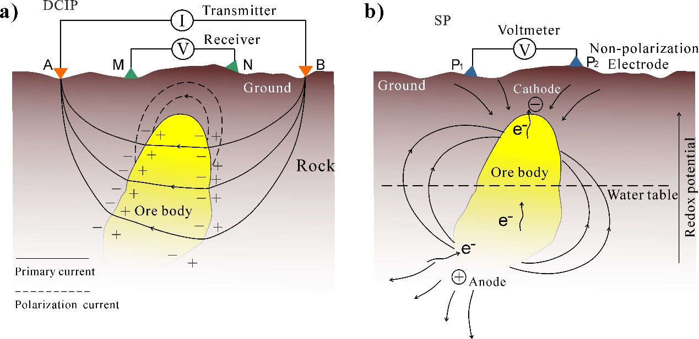

**Figure 1.** The diagram of IP and SP method. (a) DC-IP experiment showing primary current path and polarization current build up around the ore body. (b) Sketch of the geo-battery model associated with an ore body below ground surface, and negative SP anomalies generated by natural current sources are associated with redox-active environments (modified from Revil and Jardani, 2013).



**Figure 2.** Independent inversion of IP and SP datasets. First, the electrical conductivity is inverted through the electrical resistance tomography (ERT). Then, the inverted conductivity distribution is used to invert IP and SP data in terms of chargeability  and source current density distribution .

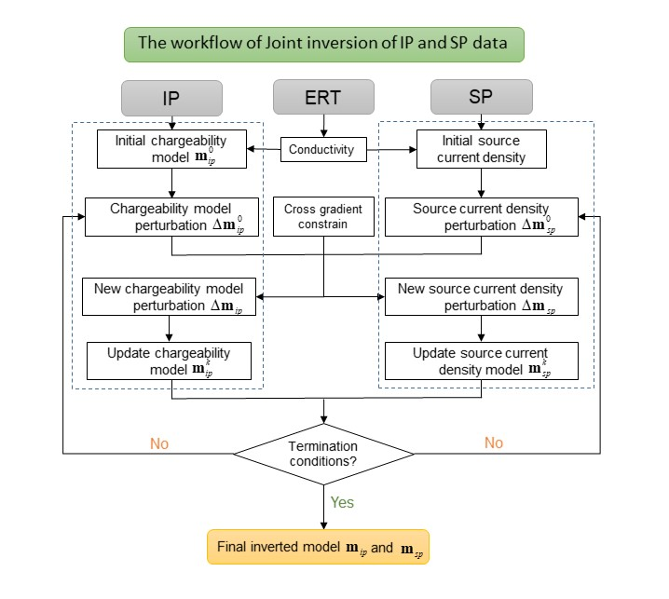

**Figure 3.** The joint inversion workflow of IP and SP data. IP, SP inversion and the cross-gradient inversion corresponding to the equation (12) – (14), respectively. The  and  are inverted chargeability and source current density from joint inversion. Here, the termination criteria are that objective function value convergence or reach to the maximum number of iterations.

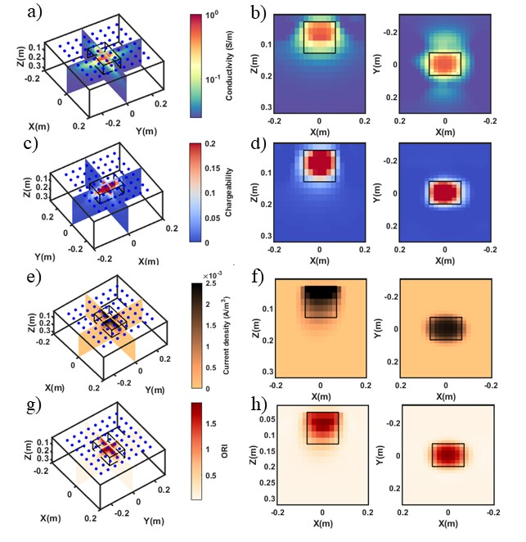

**Figure 4.** The independent inversion result of synthetic case study 1. (a) and (b) The inverted 2D and 3D conductivity distribution from ERT. (c) and (d) The inverted 2D and 3D chargeability distribution from independent IP inversion. (e) and (f) The inverted 2D and 3D current density distribution from independent SP inversion. (g) and (h) The calculated ORI distribution from independent inversion. The blue points denote the position of electrodes, and the area encapsulated by the black boxes denote the buried two anomalies.

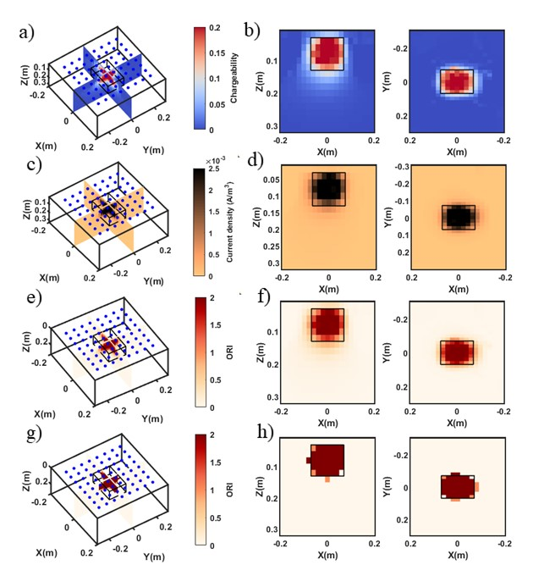

**Figure 5.** The joint inversion result of synthetic case study 1. (a) and (b) The inverted 2D and 3D chargeability distribution from joint inversion. (c) and (d) The inverted 2D and 3D current density distribution from joint inversion. (e) and (f) The calculated ORI distribution from joint inversion. (g) and (h) the ORI distribution by applying K-Medoids Clustering. The blue points denote the position of electrodes, and the area encapsulated by the black box denotes the boundary of anomaly.



**Figure 6.** Comparison of independent and joint inversion of case study 1. (a) cross-plots of the model parameter determined from independent and joint inversion (blue dots denote the inverted model parameter from independent inversion, orange dots denote inverted model parameter from the joint inversion and the big black dots denote the real model parameter). (b) Histograms of calculated ORe body Index (ORI) from independent inversion. (c) Histograms of calculated ORI from joint inversion. (d) Histograms of ORI by applying K-Medoids clustering.



**Figure 7.** The inversion result of synthetic case study 2. (a) and (b) The inverted 2D and 3D conductivity distribution from ERT. (c) and (d) The inverted 2D and 3D chargeability distribution from independent IP inversion. (e) and (f) The inverted 2D and 3D current density distribution from independent SP inversion. (g) and (h) The calculated ORI distribution from independent inversion. The blue points denote the position of electrodes, and the area encapsulated by the black/white boxes denote the buried two anomalies.



**Figure 8.** The joint inversion result of synthetic case study 2. (a) and (b) The inverted 2D and 3D chargeability distribution from joint inversion. (c) and (d) The inverted 2D and 3D current density distribution from joint inversion. (e) and (f) The calculated ORI distribution from joint inversion. (g) and (h) the ORI distribution by applying K-Medoids clustering. The blue points denote the position of electrodes, and the area encapsulated by the black/white boxes denote the anomalies.



**Figure 9.** Comparison of independent and joint inversion of case study 2. (a) Cross-plots of the model parameter determined from independent and joint inversion (blue dots denote the inverted model parameter from independent inversion, orange dots denote inverted model parameter from the joint inversion and the big black dots denote the real model parameter). (b) Histograms of calculated ORe body Index (ORI) from independent inversion. (c) Histograms of calculated ORI from joint inversion. (d) Histograms of ORI by applying K-Medoids clustering algorithm.



**Figure 10.** Experiment setup (a) A plastic tank is filled with water-saturated sand, and ABEM Terrameter SAS-4000 is used to perform both the ER and IP data measurements. (b) Two buried anomalies in () up view. (c) The height of water table during the experiment. (d) The height of buried metal bar from the front () view.



**Figure 11.** The independent inversion result of sandbox experiment. (a) and (b) The inverted 2D and 3D conductivity distribution from ERT. (c) and (d) The inverted 2D and 3D chargeability distribution from independent IP inversion. (e) and (f) The inverted 2D and 3D current density distribution from independent SP inversion. (g) and (h) The calculated ORI distribution from independent inversion result. The blue points denote the position of electrodes, and the black/white cylinder outline the true boundary of buried two anomalies.



**Figure 12.** The joint inversion result of sandbox experiment. (a) and (b) The inverted 2D and 3D chargeability distribution from joint inversion. (c) and (d) The inverted 2D and 3D current density distribution from joint inversion. (e) and (f) The calculated ORI distribution from joint inversion. (g) and (h) the ORI distribution by applying K-Medoids clustering algorithm. The blue points denote the position of electrodes, and the black/white cylinder outline the true boundary of buried two anomalies.



**Figure 13.** Comparison of independent and joint inversion of sandbox experiment. (a) Cross-plots of the model parameter determined from independent and joint inversion (blue dots denote the inverted model parameter from independent inversion, and orange dots denote inverted model parameter from the joint inversion). (b) Histograms of calculated ORe body Index (ORI) from independent inversion. (c) Histograms of calculated ORI from joint inversion. (d) Histograms of ORI by applying K-Medoids clustering algorithm.

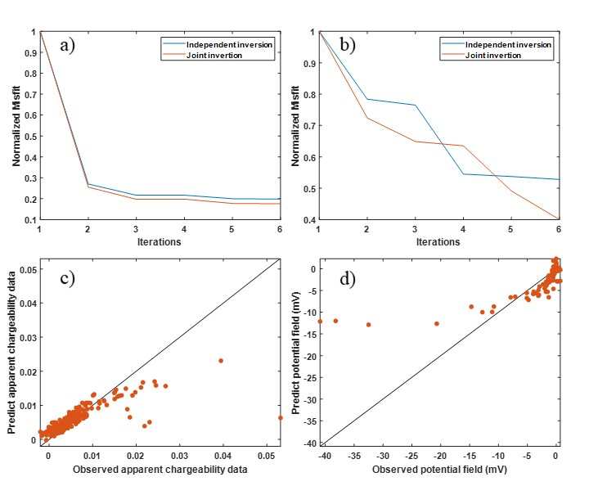

**Figure 14.** Convergence curves of independent and joint inversion and fit between the observed data and predicted data. (a) Root-mean-square (RMS) of IP data misfit (red line denotes the joint inversion and blue line denotes the independent IP inversion). (b) RMS of SP data misfit (orange line denotes the joint inversion and blue line denotes the independent inversion). (c) Observed IP data versus predicted data for the last iteration. (d) Observed SP data versus predicted data for the last iterations.